**Brand Name**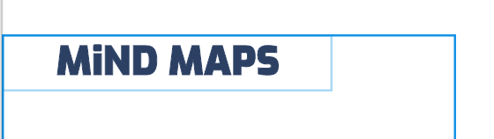

**Font Name:** Exo

**Style:** Black

**Size:** 42

**Color:** #2C4064

**Download Link:**

<https://fonts.google.com/specimen/Exo>

**Navigation Bar**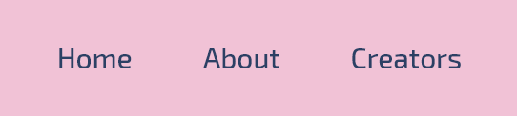

**Font Name:** Exo 2

**Style:** Medium

**Size:** 28

**Color:** #2C4064

**Download Link:**

<https://fonts.google.com/specimen/Exo+2>

**Content**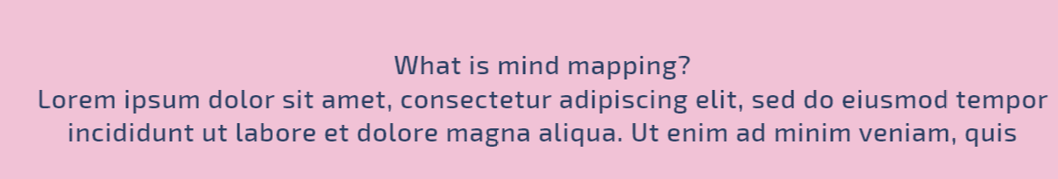

**Font Name:** Exo 2

**Style:** Medium --- Black *for bold*

**Size:** 28

**Color:** #2C4064

**Download Link:**

<https://fonts.google.com/specimen/Exo+2>

**Button Names**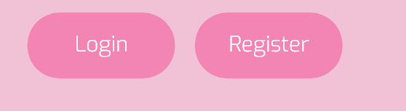

**Font Name:** Exo 2

**Style:** Light

**Size:** 28

**Color:** #FFFFFF

**Download Link:**

<https://fonts.google.com/specimen/Exo+2>

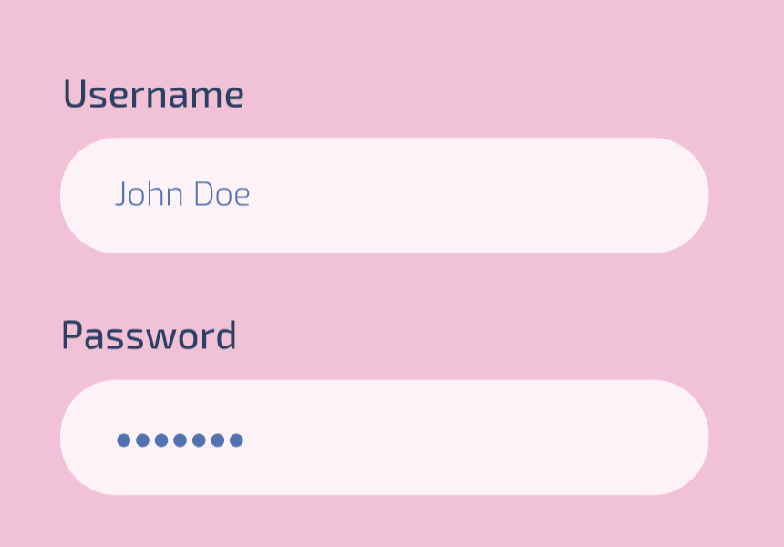

**Form**

**Font Name:** Exo 2

**Style:** Medium

**Size:** 24

**Color:** #2C4064

**Download Link:** <https://fonts.google.com/specimen/Exo+2>